Testing

🌟 Definition
# Source: AI Source: Provided by: [Data Path: Persons Table -> ID Column: 1, Name_En Column: Motasem Essam] -> From: [ChatGPT] on [6/7/2026]
Testing is the fifth phase of the Software Development Life Cycle (SDLC) where the developed software is examined to identify defects, verify requirements, and ensure the system works correctly before deployment.
The main question in this phase is:
"Does the software work correctly and meet the requirements?"

🎯 Purpose of Testing Phase
# Source: AI Source: Provided by: [Data Path: Persons Table -> ID Column: 1, Name_En Column: Motasem Essam] -> From: [ChatGPT] on [6/7/2026]
The goals of testing are to:
- Find and fix defects (bugs)
- Verify requirements are met
- Validate system behavior
- Improve software quality
- Ensure reliability and security
- Reduce risks before release

🔄 Testing Process
# Source: AI Source: Provided by: [Data Path: Persons Table -> ID Column: 1, Name_En Column: Motasem Essam] -> From: [ChatGPT] on [6/7/2026]
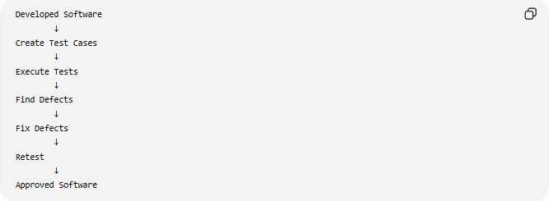
Developed Software
↓
Create Test Cases
↓
Execute Tests
↓
Find Defects
↓
Fix Defects
↓
Retest
↓
Approved Software

🧩 Main Activities in Testing

1️⃣ Test Planning
# Source: AI Source: Provided by: [Data Path: Persons Table -> ID Column: 1, Name_En Column: Motasem Essam] -> From: [ChatGPT] on [6/7/2026]
Definition
Define the testing strategy and scope.

Activities:
- Determine what to test
- Select testing methods
- Estimate testing effort
- Assign testers
- Create testing schedule

Example:
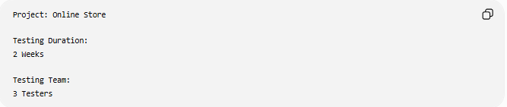
Project: Online Store
Testing Duration:
2 Weeks
Testing Team:
3 Testers

2️⃣ Test Case Design
# Source: AI Source: Provided by: [Data Path: Persons Table -> ID Column: 1, Name_En Column: Motasem Essam] -> From: [ChatGPT] on [6/7/2026]
Definition
Create detailed test scenarios.

Example
Feature:
User Login
Test Case:
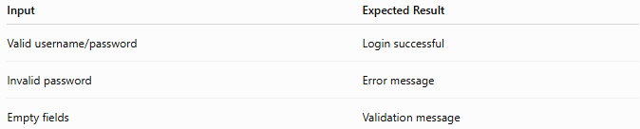
Input | Expected Result
Valid username/password | Login successful
Invalid password | Error message
Empty fields | Validation message

3️⃣ Test Environment Setup
# Source: AI Source: Provided by: [Data Path: Persons Table -> ID Column: 1, Name_En Column: Motasem Essam] -> From: [ChatGPT] on [6/7/2026]
Definition
Prepare systems needed for testing.

Example:
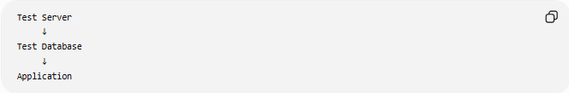
Test Server
↓
Test Database
↓
Application

Environment may include:
- Database
- Test accounts
- Test data
- Servers
- Browsers

4️⃣ Test Execution
# Source: AI Source: Provided by: [Data Path: Persons Table -> ID Column: 1, Name_En Column: Motasem Essam] -> From: [ChatGPT] on [6/7/2026]
Definition
Run test cases and compare actual results with expected results.

Example:
Test
Username: admin
Password: 123456
Expected:
Login Successful
Actual:
Login Successful
Result:
✅ Pass

5️⃣ Defect Reporting
# Source: AI Source: Provided by: [Data Path: Persons Table -> ID Column: 1, Name_En Column: Motasem Essam] -> From: [ChatGPT] on [6/7/2026]
Definition
Record bugs found during testing.

Example:
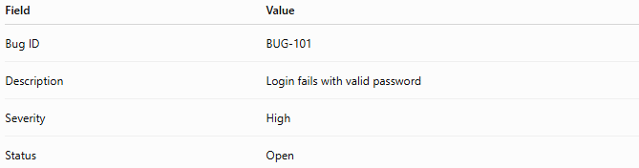
Field | Value
Bug ID | BUG-101
Description | Login fails with valid password
Severity | High
Status | Open

6️⃣ Bug Fixing and Retesting
# Source: AI Source: Provided by: [Data Path: Persons Table -> ID Column: 1, Name_En Column: Motasem Essam] -> From: [ChatGPT] on [6/7/2026]
Process:
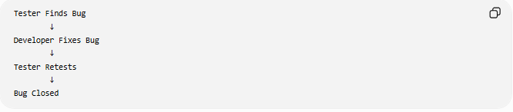
Tester Finds Bug
↓
Developer Fixes Bug
↓
Tester Retests
↓
Bug Closed

📚 Types of Testing

1️⃣ Unit Testing
# Source: AI Source: Provided by: [Data Path: Persons Table -> ID Column: 1, Name_En Column: Motasem Essam] -> From: [ChatGPT] on [6/7/2026]
Definition
Tests individual functions, methods, or modules.

Example:
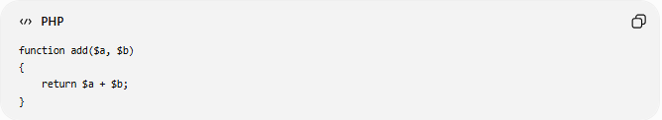
function add($a, $b)
{
return $a + $b;
}
Test:
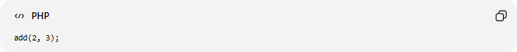
add(2, 3);
Expected:
5

2️⃣ Integration Testing
# Source: AI Source: Provided by: [Data Path: Persons Table -> ID Column: 1, Name_En Column: Motasem Essam] -> From: [ChatGPT] on [6/7/2026]
Definition
Tests communication between modules.

Example:
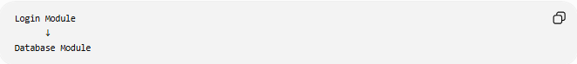
Login Module
↓
Database Module
Verify they work together correctly.

3️⃣ System Testing
# Source: AI Source: Provided by: [Data Path: Persons Table -> ID Column: 1, Name_En Column: Motasem Essam] -> From: [ChatGPT] on [6/7/2026]
Definition
Tests the complete system as a whole.

Example:
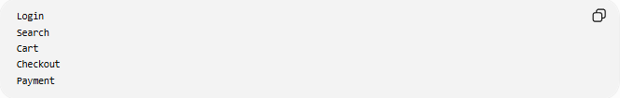
Login
Search
Cart
Checkout
Payment
All features are tested together.

4️⃣ User Acceptance Testing (UAT)
# Source: AI Source: Provided by: [Data Path: Persons Table -> ID Column: 1, Name_En Column: Motasem Essam] -> From: [ChatGPT] on [6/7/2026]
Definition
Testing performed by end users or clients.

Question:
Does the software satisfy business needs?

Example:
Store owner tests:
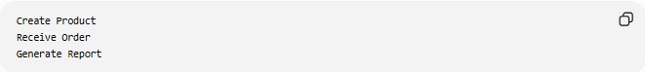
Create Product
Receive Order
Generate Report
If satisfied:
✅ Accept System

5️⃣ Regression Testing
# Source: AI Source: Provided by: [Data Path: Persons Table -> ID Column: 1, Name_En Column: Motasem Essam] -> From: [ChatGPT] on [6/7/2026]
Definition
Ensures new changes do not break existing functionality.

Example:
Add New Payment Feature
Retest:
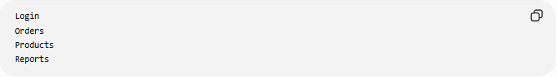
Login
Orders
Products
Reports

6️⃣ Performance Testing
Definition
Measures system speed and scalability.

Questions:
- How fast is the system?
- Can it handle many users?

Example:
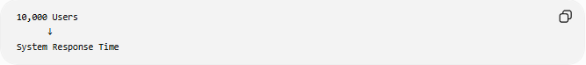
10,000 Users
↓
System Response Time

7️⃣ Security Testing
# Source: AI Source: Provided by: [Data Path: Persons Table -> ID Column: 1, Name_En Column: Motasem Essam] -> From: [ChatGPT] on [6/7/2026]
Definition
Checks protection against attacks and vulnerabilities.

Tests include:
- Authentication
- Authorization
- SQL Injection
- Data Encryption

Example:
Attempt Invalid Login
Expected:
Access Denied

📊 Manual Testing vs Automated Testing
# Source: AI Source: Provided by: [Data Path: Persons Table -> ID Column: 1, Name_En Column: Motasem Essam] -> From: [ChatGPT] on [6/7/2026]
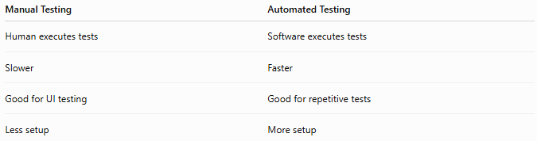
Manual Testing | Automated Testing
Human executes tests | Software executes tests
Slower | Faster
Good for UI testing | Good for repetitive tests
Less setup | More setup

🛠️ Common Testing Tools
# Source: AI Source: Provided by: [Data Path: Persons Table -> ID Column: 1, Name_En Column: Motasem Essam] -> From: [ChatGPT] on [6/7/2026]
Examples:
- JUnit
- Selenium
- Postman
- PyTest

📄 Testing Documents
# Source: AI Source: Provided by: [Data Path: Persons Table -> ID Column: 1, Name_En Column: Motasem Essam] -> From: [ChatGPT] on [6/7/2026]
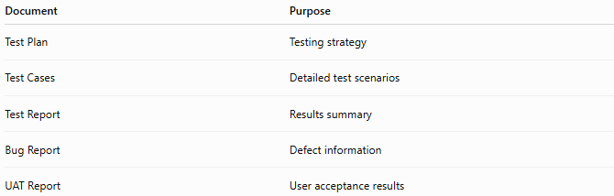
Document | Purpose
Test Plan | Testing strategy
Test Cases | Detailed test scenarios
Test Report | Results summary
Bug Report | Defect information
UAT Report | User acceptance results

📊 Output of Testing
# Source: AI Source: Provided by: [Data Path: Persons Table -> ID Column: 1, Name_En Column: Motasem Essam] -> From: [ChatGPT] on [6/7/2026]
At the end of testing:
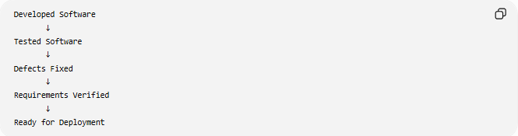
Developed Software
↓
Tested Software
↓
Defects Fixed
↓
Requirements Verified
↓
Ready for Deployment

🌍 Real-World Example
# Source: AI Source: Provided by: [Data Path: Persons Table -> ID Column: 1, Name_En Column: Motasem Essam] -> From: [ChatGPT] on [6/7/2026]
E-Commerce Website
Testers verify:
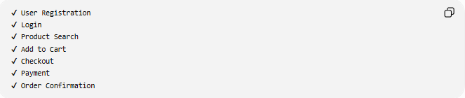
✔ User Registration
✔ Login
✔ Product Search
✔ Add to Cart
✔ Checkout
✔ Payment
✔ Order Confirmation
Any failures are reported and fixed.

🧠 Simple Analogy
# Source: AI Source: Provided by: [Data Path: Persons Table -> ID Column: 1, Name_En Column: Motasem Essam] -> From: [ChatGPT] on [6/7/2026]
Building a house:
Before Moving In
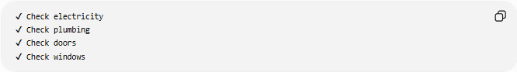
✔ Check electricity
✔ Check plumbing
✔ Check doors
✔ Check windows
Make sure everything works correctly.
Software testing does the same thing:
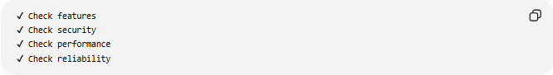
✔ Check features
✔ Check security
✔ Check performance
✔ Check reliability
before users start using the system.

🧭 Summary
# Source: AI Source: Provided by: [Data Path: Persons Table -> ID Column: 1, Name_En Column: Motasem Essam] -> From: [ChatGPT] on [6/7/2026]
The Testing Phase is the SDLC stage where the software is examined to verify that it meets requirements and works correctly. Testers execute test cases, identify defects, validate functionality, and ensure quality through various testing types such as Unit Testing, Integration Testing, System Testing, UAT, Performance Testing, and Security Testing. The output is a reliable, tested application ready for deployment.

